Graph 1:

The graph shows the comparison number of men’s population of different age groups between 2011 and 2016 censuses. It explains what quantity of each age group and compares it with other census result. 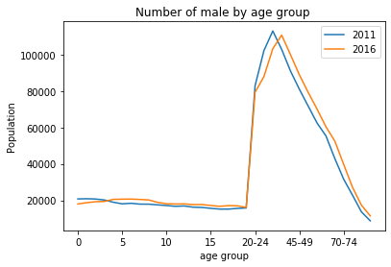

Graph 2:

The graph shows the comparison number of women’s population of different age groups between 2011 and 2016 censuses. It explains what quantity of each age group and compare it with other census result.

